MODULE 1- CSS
Theme: Styling the "Local Community Event Portal"

NAME: SHUBHASHREE MANIKANDAN
SUPERSET ID: 6742954

TASK 1: Why CSS? Inline vs. Internal vs. External
CODE:
<!DOCTYPE html>
<html>
<head>
<style>
body{
background-color:lightblue;
}
</style
<link rel="stylesheet" href="styles.css">
</head>
<body>
<h1 style="color:red;">Community Event Portal</h1>
<h2 class="heading">Welcome Users</h2>
</body>
</html>

OUTPUT:
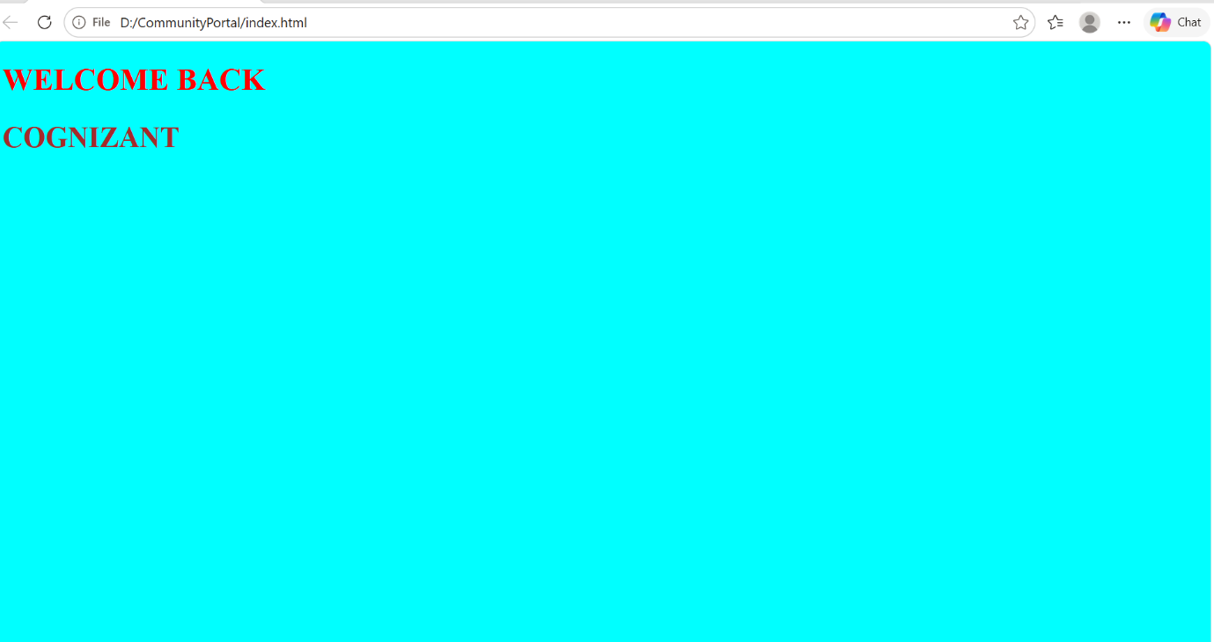

TASK 2: CSS Syntax and Comments
CODE:
/* Style for main button */
.cta-button{
background-color:#007BFF;
color:white;
padding:10px;
border:none;
}
/* Description Text */
.description{
font-size:18px;
color:black;
}

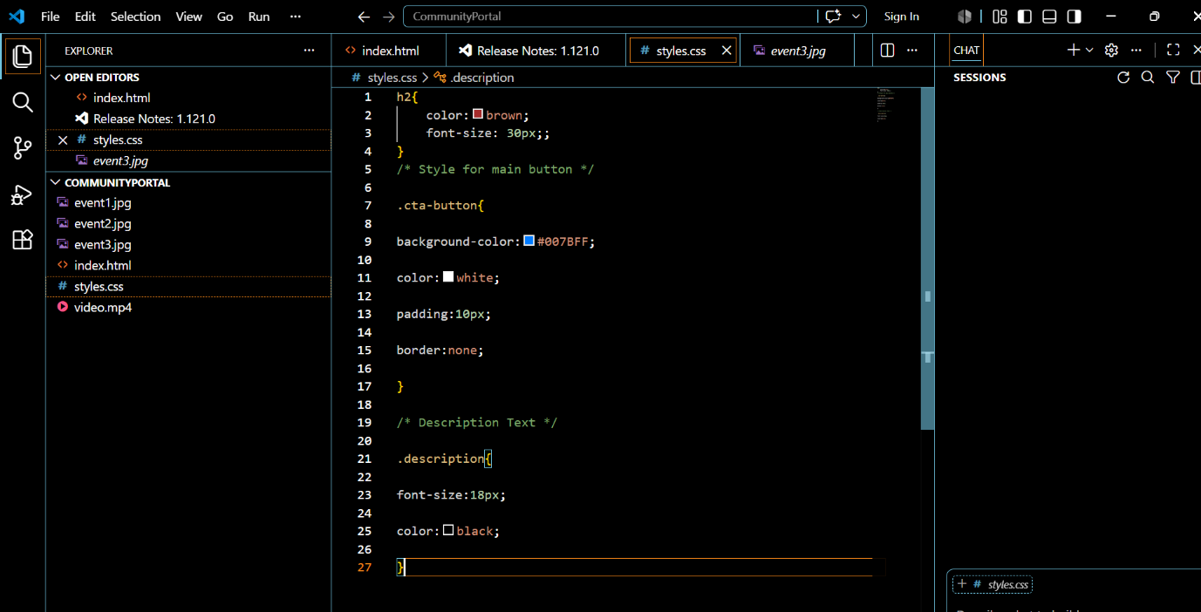
OUTPUT:

TASK 3: Selectors Playground
CODE:
HTML:
<body>
<h1 id="mainHeader">SELECTOR TYPES</h1>
<!-- <h1 style="color:red;">WELCOME BACK</h1> -->
<div class="eventcard">
<h2>COGNIZANT</h2>
<h2>I LOVE CODING</h2>
<h3>Group selector</h3>
<p> grouped with h3</p>
</div>
</body>
CSS:
*{
padding:15px;
font-size:35px;
}
h2{
color:black;
}
#mainHeader{
color:beige;
}
.eventcard{
border:#007BFF;
border-radius:3px;
}
h3,p{
color:cornflowerblue;
font-size:40px;}
OUTPUT:
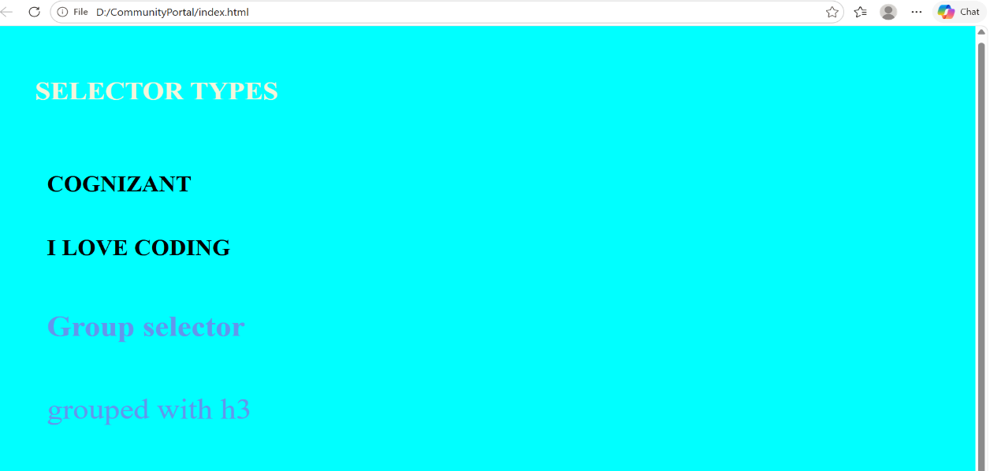

TASK 4: Color & Background Styling
CODE:
body{
background-image:url("bg.avif");
background-color:#f2f2f2;
}

h2{
color:#000000;
background:rgba(0,0,255,0.3);
}
header{
background:linear-gradient(to right,blue,purple);
padding:20px;
}

OUTPUT:
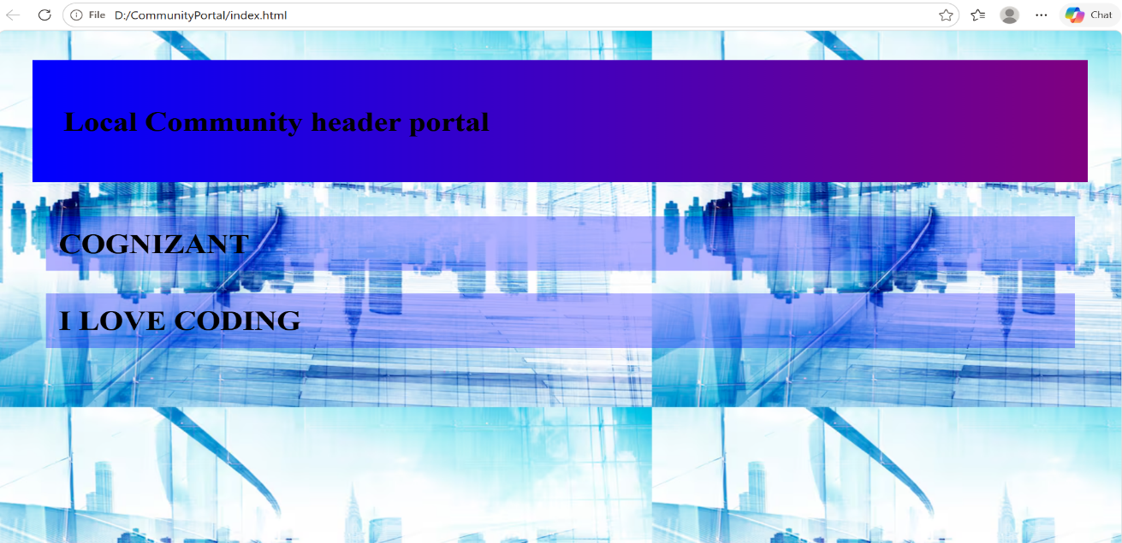

TASK 5: Typography: Fonts and Text
CODE:
.text{
font-family:Poppins;
font-size:22px;
font-style:italic;
font-weight:bold;
text-align:center;
text-transform:uppercase;
letter-spacing:3px;
line-height:35px;
}

OUTPUT:
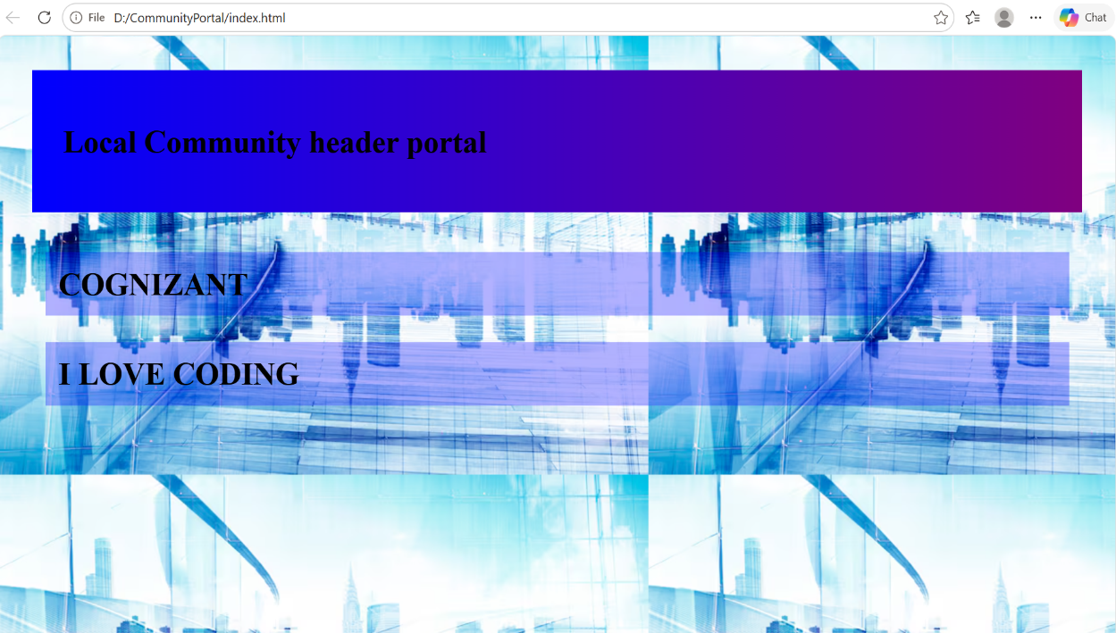

TASK 6: Link and List Styling
CODE:
a:link{
color:blue;
a:hover{
color:red;
}
a:active{
color:green;
}
a:visited{
color:purple;
}
.menu{
list-style-type:none;
list-style-position:inside;
}
.menu li{
padding:10px;
margin:5px;
}
OUTPUT:
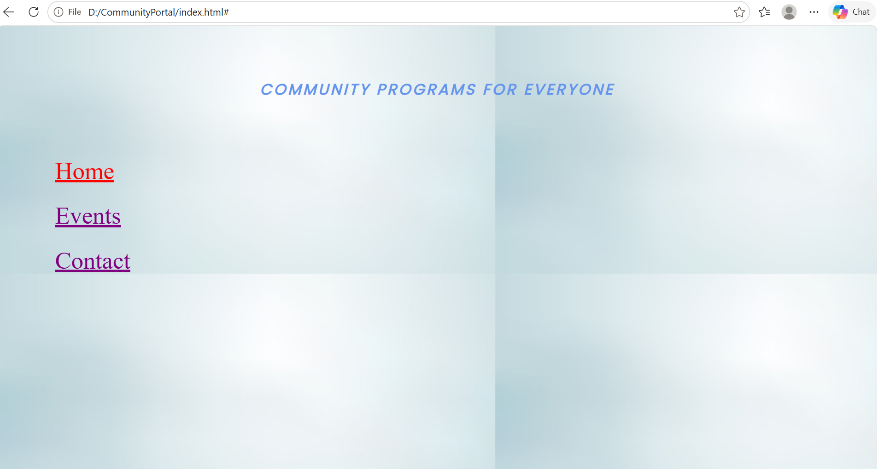

TASK 7: Table Styling
CODE:
<table>
<tr>
<th>Event</th>
<th>Date</th>
</tr>
<tr>
<td>Festival</td>
<td>June 10</td>
</tr>
<tr>
<td>Music</td>
<td>June 20</td>
</tr>
</table>
CSS:
table{
border-collapse:collapse;
width:100%;
text-align:center;
}
th,td{
border:1px solid black;
padding:10px;
}
tr:nth-child(even){
background:lightgray;
}

OUTPUT:
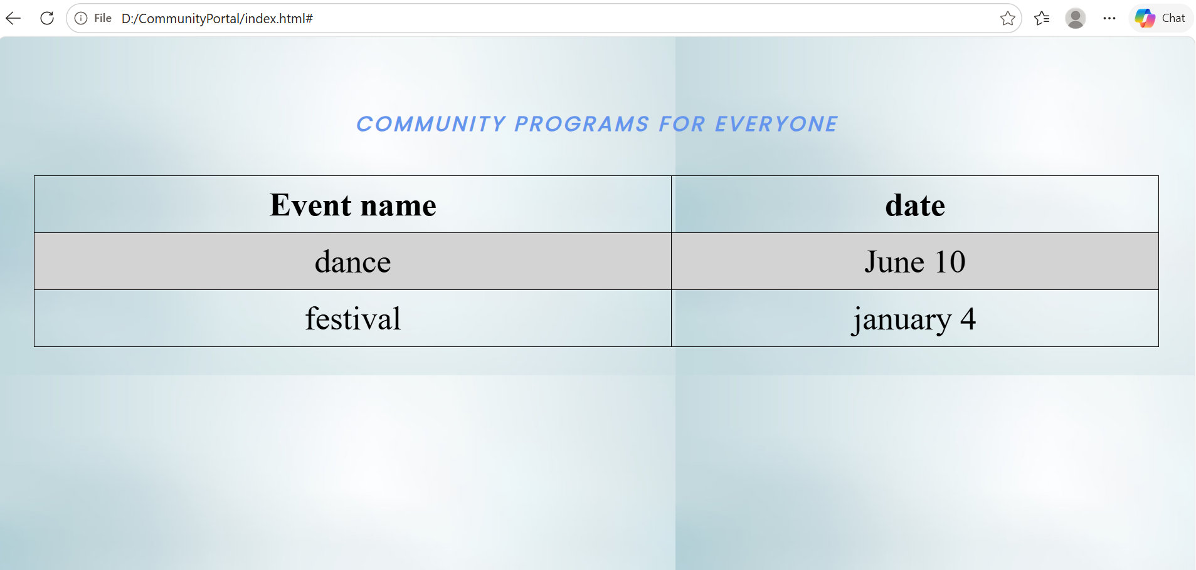

TASK 8: Box Model & Layout Control
CODE:
.eventCard
border:2px solid black;
padding:20px;
margin:20px;
outline:2px solid blue;
}
input:focus{
outline:3px solid red;}
.hide1{
visibility:hidden;
}
.hide2{
display:none;
}

OUTPUT:
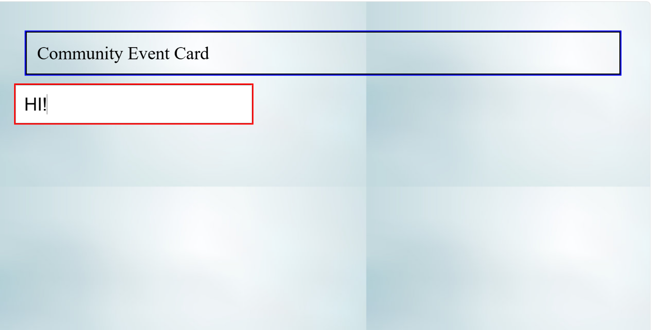

TASK 9: Multiple Columns in Text
CODE:
.article{
column-count: 4;
column-gap: 30px;
column-rule: 1px solid gray;
}
OUTPUT:
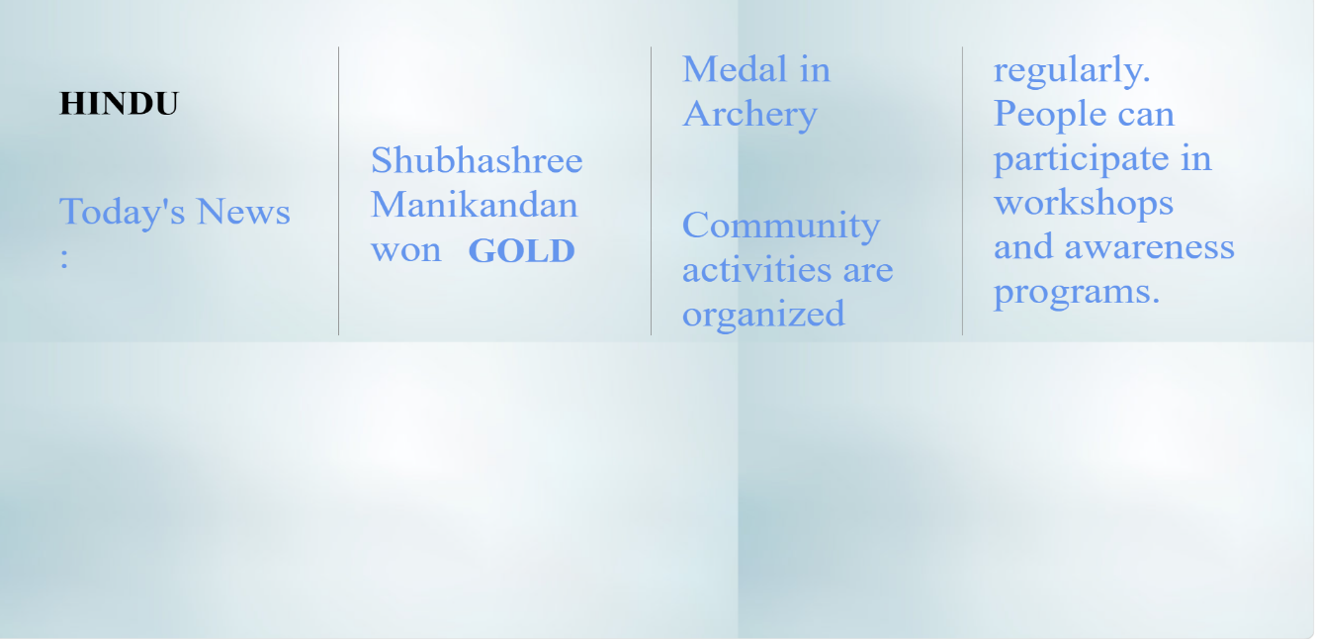

TASK 10: Responsive Web Design with Media Queries
CODE:
.nav{
display:flex;
gap:20px;
}
@media screen and (max-width:768px){
.nav{
flex-direction:column;
}
body{
font-size:14px;}
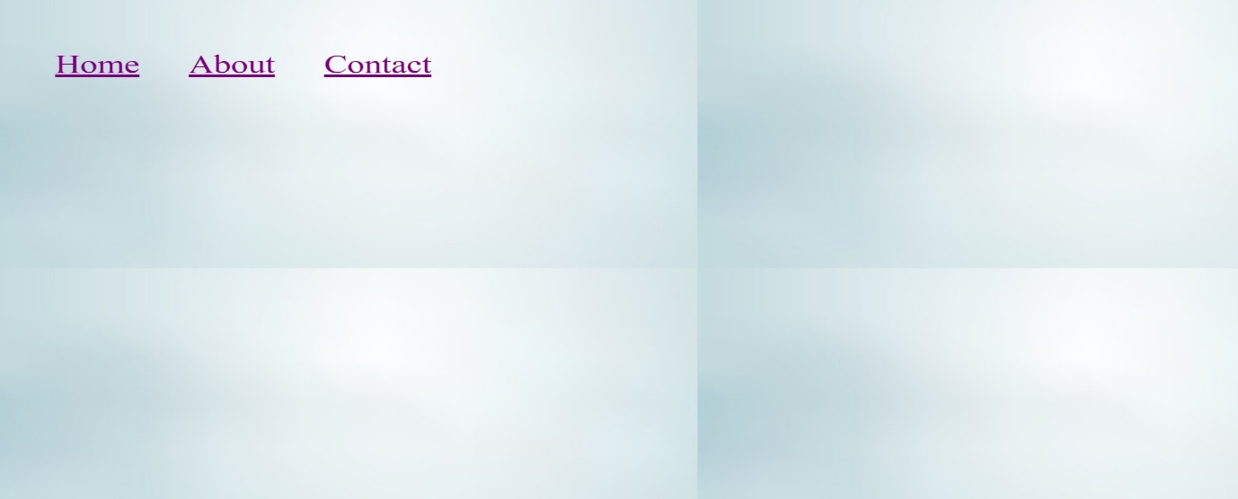
OUTPUT:

TASK 11: Debug and Test with Dev Tools and VS Code

